**Module 2 Kinematics of particles**

**Motion Curves**

1. A bicycle moves along a straight road such that its position is described by the graph shown in Fig. Construct the v-t and a-t graphs for t=0 to 30 seconds. Displacement in mm.

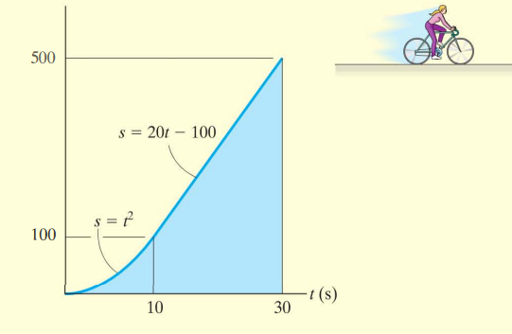

2. The car in Fig. starts from rest and travels along a straight track such that it accelerates at 10 m/s² for 10 s, and then decelerates at 2 m/s². Draw the v-t and s-t graphs and determine the time t' needed to stop the car. How far has the car travelled?

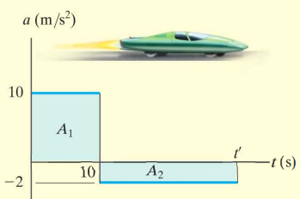

3. The sports car travels along a straight road such that its position is described by the graph. Construct the v-t and a-t graphs for the time interval t=0 to 10 seconds.

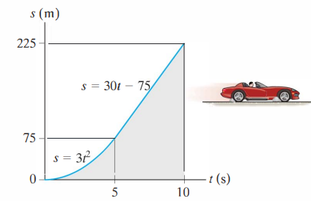

4. A two-stage missile is fired vertically from rest with the acceleration shown. In 15 s the first stage A burns out and the second stage B ignites. Plot the v-t and s-t graphs which describe the two-stage motion of the missile for t=0 to 20 seconds.

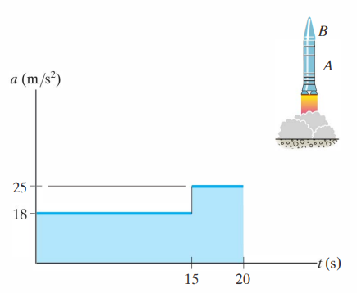

5. A car starts from rest and travels along a straight road with a velocity described by the graph. Determine the total distance travelled until the car stops. Construct the s-t and a-t graphs.

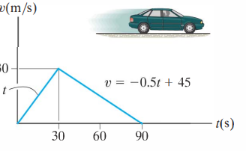

6. A missile starting from rest travels along a straight track and for 10 s has acceleration as shown. Draw the v-t graph that describes the motion and find the distance travelled in 10 s.

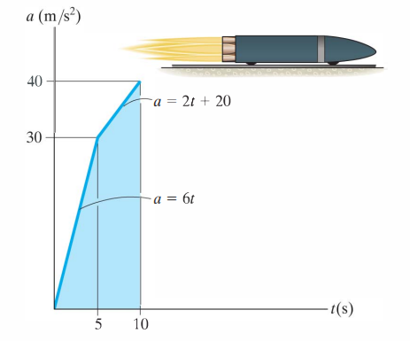

7. The a-t curve for a particle performing rectilinear motion is as shown in fig. At t=0 the particles velocity is 5 m/s and particle is located at 25m to the left of origin. Find the velocity and position at 6,12 and 18 seconds.

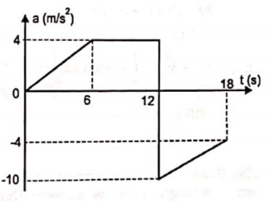

8. Draw v-t and x-t curves if particle starts from rest and origin.

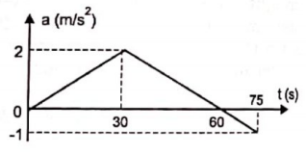

9. Draw v-t and x-t curves if particle starts with a velocity of 5 m/s from origin.

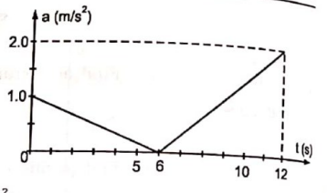

**10. The position of a cyclist travelling along a straight road is as shown in figure. Draw V-t and a-t graphs.**

